Coins-Constans (337 to 350)-AE 4-GLORIA EXERCITVS

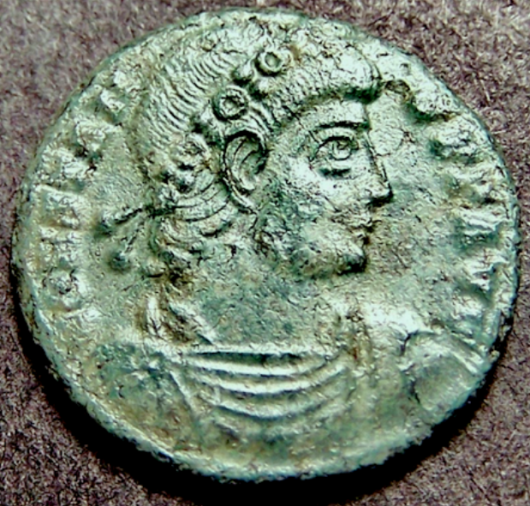 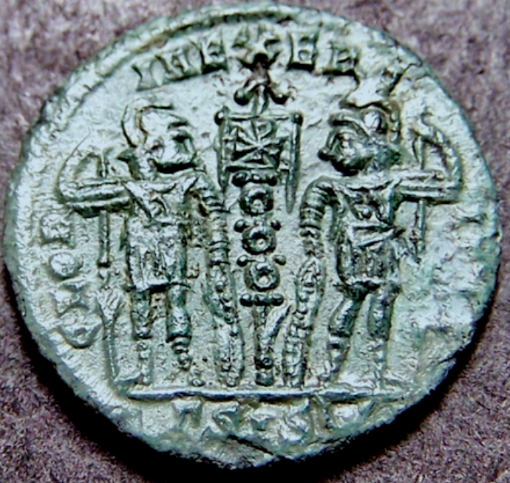

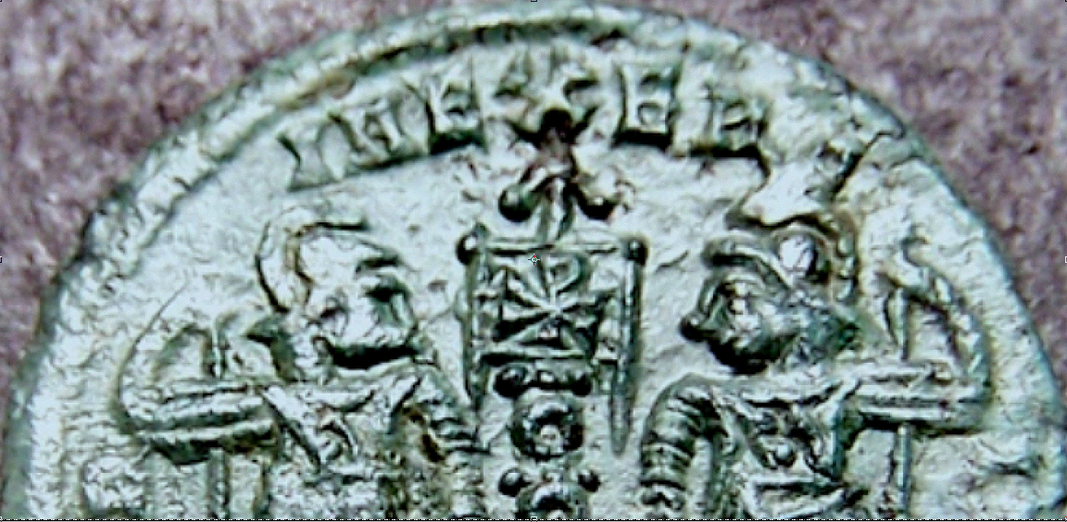

GLORIA EXERCITVS

This Roman coin is known as the "Glory of the Army" or simply the "Soldiers and Standards" coin. This coin is also known as a "Behold, the glorious army of new Rome".   These coins were introduced in the 330's by Constantine I (the Great) and various members of his family - sons and Caesars Constantine II, Constantius II, and Constans, in addition to his nephew, Delmatius Caesar.  The type shows two soldiers each holding a spear and a shield.  Between them, on the early issues, are two standards that consist of a stack of medallions on a pole.  Like many coins of this period they were decreased in size during the period of their issue.  Just before his death in 337 A.D., Constantine I reduced the size of the nummus (also called a follis) which was marked by the change from two standards to one shared standard. Consequently, one can find both one standard and two-standard coins bearing Constantine the Great's name. They are good examples of how the Roman emperors of this time used coins as official propaganda.

The reverse of this coin depicts a Chi-Rho emblem. This christogram is formed by superimposing the first two letters in the Greek spelling of the word Christ (Greek: "Χιστός"), chi = Χ and rho = ****, in such a way to produce the monogram **☧**.   Constantine the Great was said to have seen this symbol in a vision the night before the Milvian Bridge battle just outside of Rome in 312 AD.  The next day he reportedly ordered his soldiers to paint the symbol on their shields. Subsequently, the ☧ banner (called a labarum) led Roman troops into battle for centuries to kill adversaries in the name of Christ, and it is still used in Christian worship today.

This coin was minted in the ancient Roman city of Segestica in Upper Pannonia (modern Siscia, Sisak, Croatia) (45.46611, 16.37833). It was minted in the 3rd (gamma) officina.  Here are its attributes:

CONSTANS,  AE4 (16 mm, 1.16 gm)

OBV:  CONSTAN-S PF AVG, rosette-diademed, draped, cuirassed bust right

REV:  GLOR-IA EXERC-ITVS, two soldiers holding spears and shields with one standard between them, chi-rho on banner.

EXE:  gamma SIS dot in crescent    Siscia mint      RIC 99

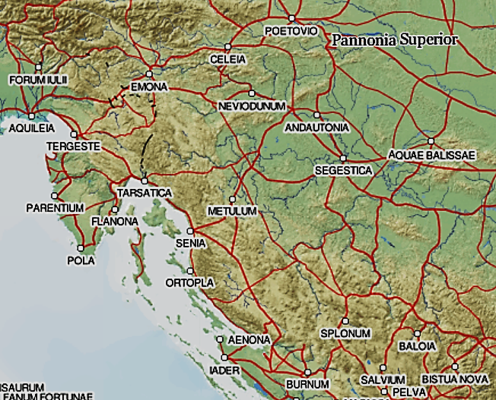

After http://dare.ht.lu.se/places/10771.html